# PART 1 IWED

Dineo Malatji

ST10359006

Business Background

Name: CookingWithDr

Location: Sandton, South Africa

Type of Business: Catering business

Products/ Services: Weekly Meal Preps; Private Chef Services; and Event Catering

## Motivation for Website

* Passion for serving good food: The inspiration comes from the satisfaction of serving others good food.
* Overtake the competition: To take over the competition because not a lot of them really have websites and our plan was to make a nice website showcasing our work and making the process of requesting a quote very seamless and easy for our visitors.
* Terrible Market conditions: Furthermore, the terrible service other catering companies provide to their customers.

Objectives for having a website for this business

* Easier customer journey: Seamless access to our work and requesting a quote from us.
* Brand Awareness and traffic: More people towards our business.
* Referrals: Word of mouth and more reviews for the business.
* Professionalism: Look more professional to visitors.

## Resources required for creating the website

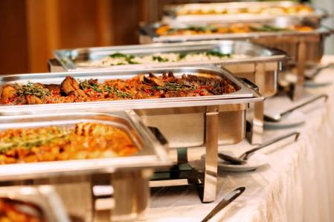

Figure 1 (iStock, 2022 )

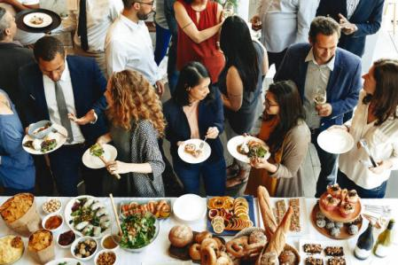

Figure 2 (iStock, 2015 )

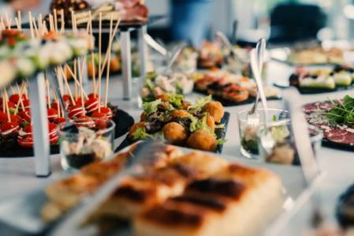

Figure 3 (iStock, 2014)

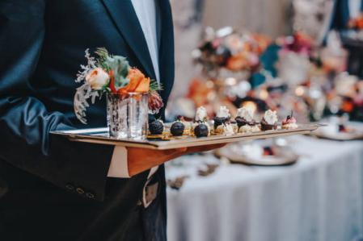

Figure 4 (iStock, 2017)

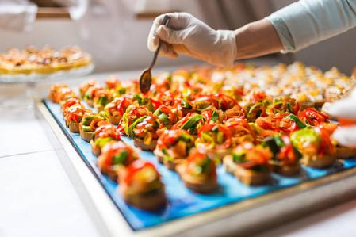

Figure 5 (iStock, 2016)

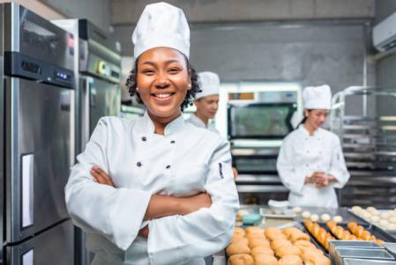

Figure 6 (iStock, 2023)

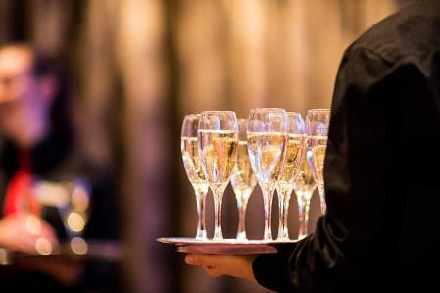

Figure 7 (iStock, 2018)

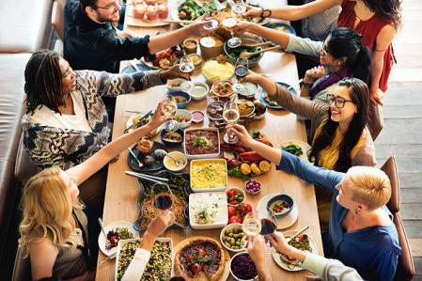

Figure 8 (iStock, 2017)

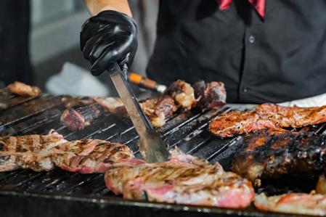

Figure 9 (iStock, 2018)

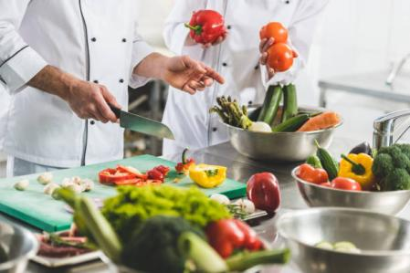

Figure 10 (iStock, 2025)

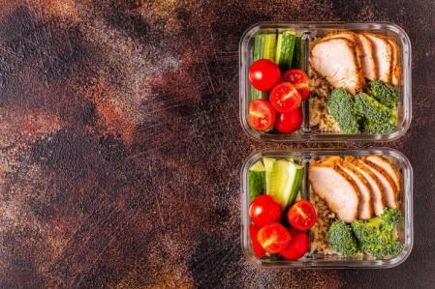

Figure 11 (iStock, 2018)

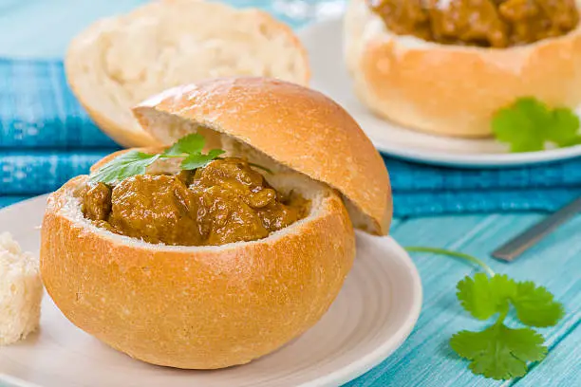

Figure 12 (iStock, 2020)

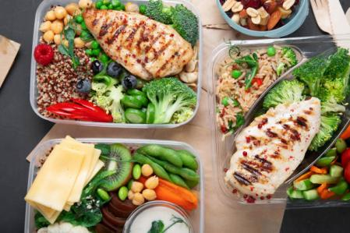

Figure 13 (iStock, 2021)

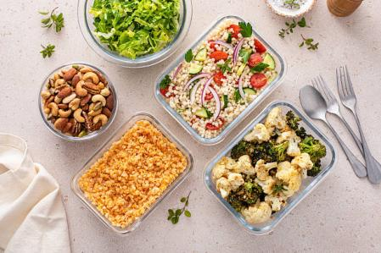

Figure 14 (iStock, 2013)

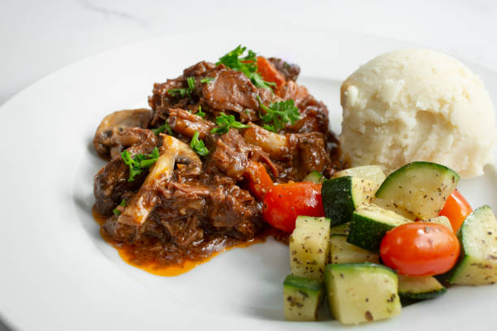

Figure 15 (iStock, 2025)

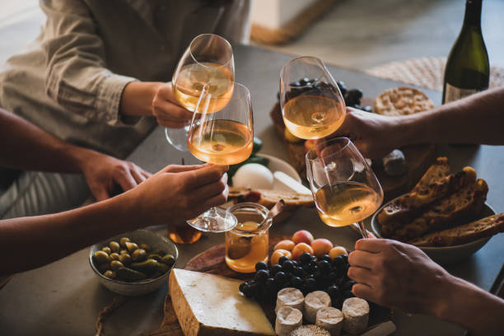

Figure 16 (iStock, 2014)

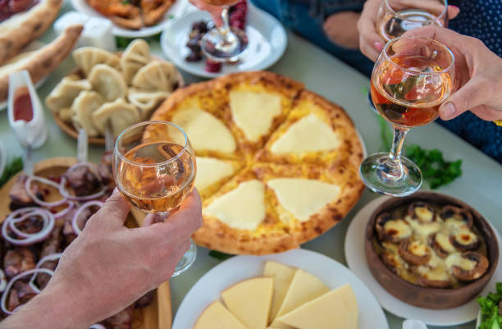

Figure 17 (iStock, 2021)

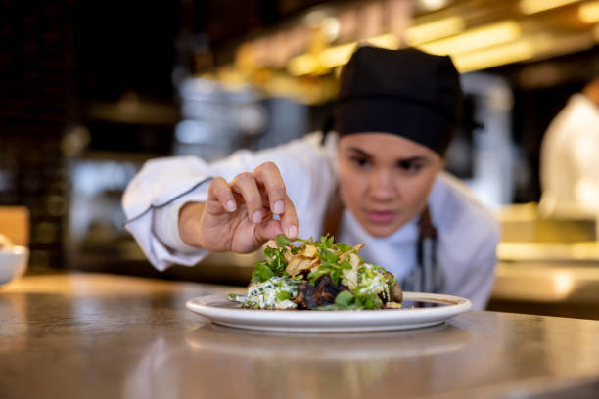

Figure 18 (iStock, 2022)

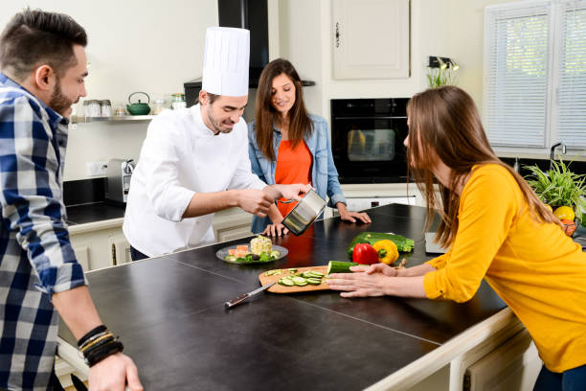

Figure 19 (iStock, 2022)

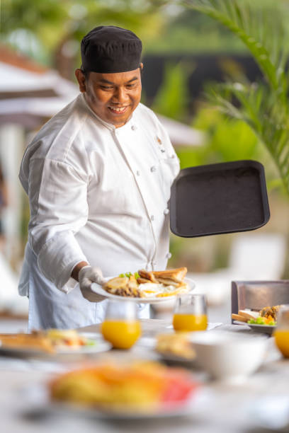

Figure 20 (iStock, 2019)

CSS Stylng

I added custom CSS styling to enhance the visual appearance of the web-page.

Styles were applied to tables, images, and captions to create a clean and organized layout.

I used consistent font sizes and colors to improve readability and user experience.

Margins and padding were adjusted to ensure elements were spaced evenly.

Overall, the styling contributes to a more professional and visually appealing presentation.

## Sitemap

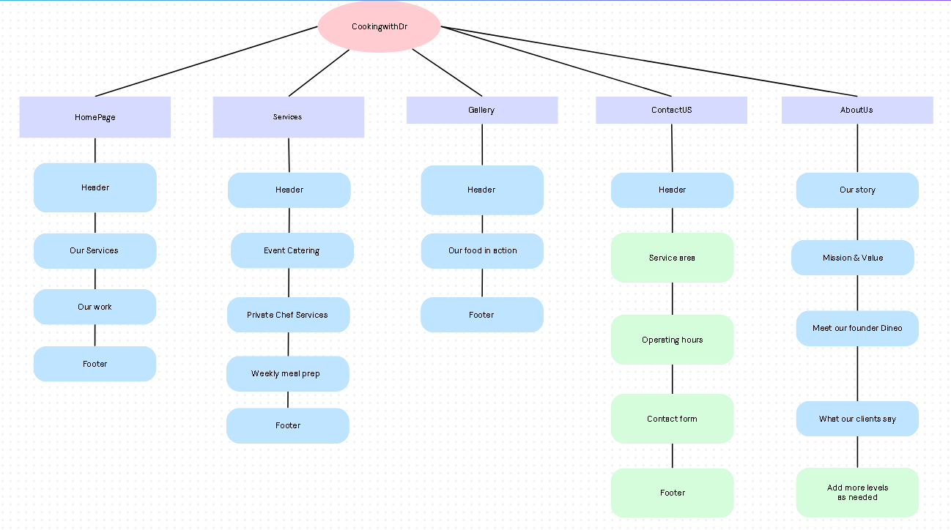

User Persona

Thando Mokwena

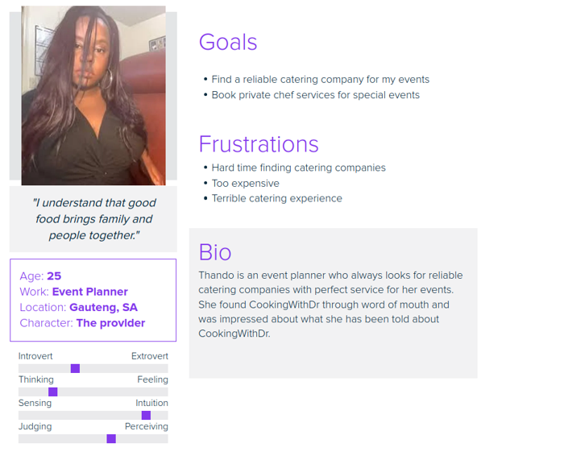

Reference List

[Anon-tae](https://www.istockphoto.com/portfolio/anon-tae?mediatype=photography). (2022) African American woman bakers looking at camera chef baker in a chef dress and hat cooking together in kitchen she takes fresh baked cookies out of modern electric oven in kitchen. [Photograph]. iStock. Available at: [https://www.istockphoto.com/photo/african-american-woman-bakers-looking-at-camera-chef-baker-in-a-chef-dress-and-hat-gm1389857295-447006096](https://www.istockphoto.com/photo/african-american-woman-bakers-looking-at-camera-chef-baker-in-a-chef-dress-and-hat-gm1389857295-447006096" \t "_new) (Accessed: 21 April 2025).

**ImageGap.** (2015) Champagne reception. [Photograph]. iStock. Available at: [https://www.istockphoto.com/photo/champagne-reception-gm534604567-56878114](https://www.istockphoto.com/photo/champagne-reception-gm534604567-56878114" \t "_new) (Accessed: 21 April 2025).

**Razyph.** (2014) Final touch for tasty canapés. [Photograph]. iStock. Available at: [https://www.istockphoto.com/photo/final-touch-for-tasty-canapes-gm498472863-42102584](https://www.istockphoto.com/photo/final-touch-for-tasty-canapes-gm498472863-42102584" \t "_new) (Accessed: 21 April 2025).

**Rawpixel.** (2017) Food catering cuisine culinary gourmet buffet party concept. [Photograph]. iStock. Available at: [https://www.istockphoto.com/photo/food-catering-cuisine-culinary-gourmet-buffet-party-concept-gm826608862-134289187](https://www.istockphoto.com/photo/food-catering-cuisine-culinary-gourmet-buffet-party-concept-gm826608862-134289187" \t "_new) (Accessed: 21 April 2025).

**Rawpixel.** (2016) Brunch choice crowd dining food options eating concept. [Photograph]. iStock. Available at: [https://www.istockphoto.com/photo/brunch-choice-crowd-dining-food-options-eating-concept-gm526546790-92598311](https://www.istockphoto.com/photo/brunch-choice-crowd-dining-food-options-eating-concept-gm526546790-92598311" \t "_new) (Accessed: 21 April 2025).

Serts. (2023) Luxury delicious appetizer serving. [Photograph]. iStock. Available at: [https://www.istockphoto.com/photo/luxury-delicious-appetizer-serving-gm1472804671-503066143](https://www.istockphoto.com/photo/luxury-delicious-appetizer-serving-gm1472804671-503066143" \t "_new) (Accessed: 21 April 2025).

**[Dusanpetkovic](https://www.istockphoto.com/portfolio/dusanpetkovic?mediatype=photography). (**2018) Table decoration of beautiful tasty food on celebration day. [Photograph]. iStock. Available at: [https://www.istockphoto.com/photo/table-decoration-of-beautiful-tasty-food-on-celebration-day-gm1029200760-275831116](https://www.istockphoto.com/photo/table-decoration-of-beautiful-tasty-food-on-celebration-day-gm1029200760-275831116" \t "_new) (Accessed: 21 April 2025).

**[LElik83](https://www.istockphoto.com/portfolio/Olga_Molleker?mediatype=photography). (**2017) Catering food wedding event table. [Photograph]. iStock. Available at: [https://www.istockphoto.com/photo/catering-food-wedding-event-table-gm650655146-118180751](https://www.istockphoto.com/photo/catering-food-wedding-event-table-gm650655146-118180751" \t "_new) (Accessed: 21 April 2025).

**[LightFieldStudios](https://www.istockphoto.com/portfolio/LightFieldStudios?mediatype=photography). (**2018) Cropped image of chefs preparing vegetables at restaurant kitchen. [Photograph]. iStock. Available at: [https://www.istockphoto.com/photo/cropped-image-of-chefs-preparing-vegetables-at-restaurant-kitchen-gm941450452-257320700](https://www.istockphoto.com/photo/cropped-image-of-chefs-preparing-vegetables-at-restaurant-kitchen-gm941450452-257320700" \t "_new) (Accessed: 21 April 2025).

**Photo-lime. (**2025) Chef grilling steaks over open flame. [Photograph]. iStock. Available at: [https://www.istockphoto.com/photo/chef-grilling-steaks-over-open-flame-gm2206865895-624150063](https://www.istockphoto.com/photo/chef-grilling-steaks-over-open-flame-gm2206865895-624150063" \t "_new) (Accessed: 21 April 2025).

**[Tbralnina](https://www.istockphoto.com/portfolio/tbralnina?mediatype=photography). (**2018) Healthy balanced lunch box with chicken rice vegetables. [Photograph]. iStock. Available at: [https://www.istockphoto.com/photo/healthy-balanced-lunch-box-with-chicken-rice-vegetables-gm1071409180-286717133](https://www.istockphoto.com/photo/healthy-balanced-lunch-box-with-chicken-rice-vegetables-gm1071409180-286717133" \t "_new) (Accessed: 21 April 2025).

**Bit245.** (2020) Takeaway lunch boxes with homemade nutrition food. [Photograph]. iStock. Available at: [https://www.istockphoto.com/photo/takeaway-lunch-boxes-with-homemade-nutrition-food-gm1291897301-386876573](https://www.istockphoto.com/photo/takeaway-lunch-boxes-with-homemade-nutrition-food-gm1291897301-386876573" \t "_new) (Accessed: 21 April 2025).

**Paul\_Brighton.** (2013) Bunny chow. [Photograph]. iStock. Available at: [https://www.istockphoto.com/photo/bunny-chow-gm453069827-30094254](https://www.istockphoto.com/photo/bunny-chow-gm453069827-30094254" \t "_new) (Accessed: 21 April 2025).

**[Photography By Tonelson](https://www.istockphoto.com/portfolio/PhotographyByTonelson?mediatype=photography).** (2025) Beef bourguignon starter. [Photograph]. iStock. Available at: [https://www.istockphoto.com/photo/beef-bourguignon-starter-gm2194798431-612927056](https://www.istockphoto.com/photo/beef-bourguignon-starter-gm2194798431-612927056" \t "_new) (Accessed: 21 April 2025).

**zeljkosantrac**. (2014) South African potjiekos top view. [Photograph]. iStock. Available at: [https://www.istockphoto.com/photo/south-african-potjiekos-top-view-gm483748119-36549474](https://www.istockphoto.com/photo/south-african-potjiekos-top-view-gm483748119-36549474" \t "_new) (Accessed: 21 April 2025).

[Foxys\_forest\_manufacture](https://www.istockphoto.com/portfolio/Foxys_forest_manufacture?mediatype=photography). (2021) *Friends having wine tasting or celebrating event with wine* [Photograph]. Available at: <https://www.istockphoto.com/photo/friends-having-wine-tasting-or-celebrating-event-with-wine-gm1333075831-415720353> (Accessed: 23 April 2025).

[Yana Tatevosian](https://www.istockphoto.com/portfolio/YanaTatevosian?mediatype=photography). (2022) *Georgian cuisine food in a restaurant (selective focus)* [Photograph]. Available at: <https://www.istockphoto.com/photo/georgian-cuisine-food-in-a-restaurant-selective-focus-gm1394418632-449905352> (Accessed: 23 April 2025).

[Hispanolistic](https://www.istockphoto.com/portfolio/Hispanolistic?mediatype=photography). (2022) *Chef decorating a plate while working at a commercial kitchen* [Photograph]. Available at: <https://www.istockphoto.com/photo/chef-decorating-a-plate-while-working-at-a-commercial-kitchen-gm1409730044-460179393> (Accessed: 23 April 2025).

Ventz. (2024) *Luxury holiday vacation private villa chef preparing breakfast* [Photograph]. Available at: <https://www.istockphoto.com/photo/luxury-holiday-vacation-private-villa-chef-preparing-breakfast-gm2154534124-575398444> (Accessed: 23 April 2025).

[Jean-philippe WALLET](https://www.istockphoto.com/portfolio/JPWALLET?mediatype=photography). (2017) *Professional personal chef cook in customer’s private kitchen house giving a cooking class* [Photograph]. Available at: <https://www.istockphoto.com/photo/professional-personal-chef-cook-in-customers-private-kitchen-house-giving-a-cooking-gm656811172-119619261> (Accessed: 23 April 2025).

ClarkandCompany. (2019) *Chef preparing a dish of venison with apple and seasonal vegetables* [Photograph]. Available at: <https://www.istockphoto.com/photo/chef-preparing-a-dish-of-venison-with-apple-and-seasonal-vegetables-gm1186342409-334689050> (Accessed: 23 April 2025).